OBJECTIVES OF THE PROJECT AT HORNÍKOVA PRIVATE VOCATIONAL SCHOOL:
- make a short animated film
- create a set of teaching materials for physics

PROJECT ANNOTATION:
The project is aimed at supporting pupils' media literacy. During the project, students will learn about the creation of a media message not only in terms of its content, but also in its technical aspect. By filming videos of school events and processing them, the students will then be actively involved in the life of the school.
Individual outputs will connect several subjects (Czech language, physics, computer science).

Name of the sub-project: A set of teaching videos for physics
Project goal:
One of the sub-goals of the DigiMe project at our school was to create a set of supporting videos that can be used as a supplement to teaching, while the creation itself was
on the shoulders of pupils.

Necessary equipment
- camera/video camera
- aids for relevant physics experiments (e.g. video Compass from a needle – magnet, bowls of water, needles, compass, paper and crayons, etc.)
- voltage source (in the case of electrical experiments)
- video and audio editing software (e.g. Pinnacle, Video Editor Windows, Audacity, OneShot Video Editor, XMedia Recode...)

Project schedule
The entire process of creating individual videos was quite simple and could be summarised in the following few steps.

Choosing a topic
First, the students chose the topic they were interested in working on, the choice was purely up to them, I did not present them with a list from which they chose. Subsequently, it was necessary for the students to repeat/study the necessary materials for the creation, regarding the phenomena that will be captured on the video recordings and to be able to describe the phenomenon correctly. In some cases, it was also necessary for the pupils to familiarise themselves with the functionality of some of the necessary devices.
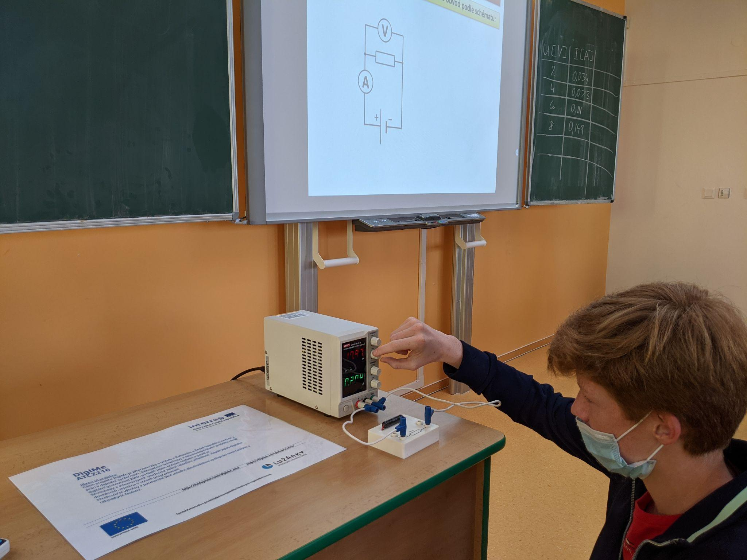
Ohm's Law (unrealized part of the set). Getting to know the new voltage source.

Creating a scenario
After studying, they had the task of preparing a "script" for the individual videos. Everything essential was mentioned in the script, from welcoming the "spectators", to the introduction of the experiment, the list of necessary aids, the execution of the experiment itself, to the final summary and saying goodbye to the audience. The creation of the scenario was on the shoulders of the pupils, and I was responsible for subsequent comments, proofreading and agreement on the final form.

Shooting
Wave transmission using beads. Draft part of the script.
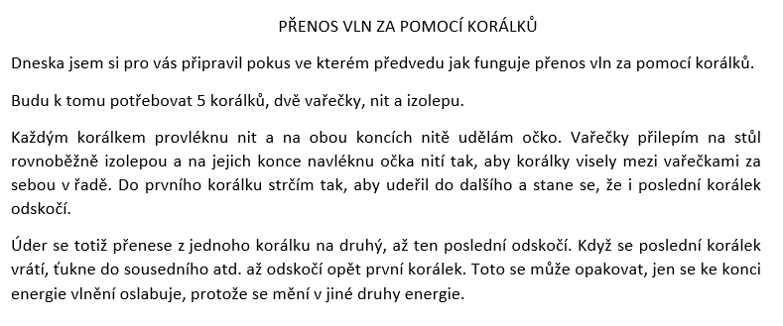
Wave transmission using beads. Draft part of the script.

Picture translation: Wave transmission using beads
Today I have prepared an experiment for you in which I will show you how wave transmission works using wires.
I will need 5 beads, 2 spatulas, thread and scotch tapeI.
I will push the thread through each bead and make a loop at both ends. I will stick the wooden spoons parallel to the table with insulating tape and thread loops of thread on their ends so that the beads hang between the wooden spoons one behind the other in rows. I push the first bead so that it hits the next one and it happens that the last bead also bounces off.
The impact is carried from one bead to the next until the last one bounces. When the last bead returns, it taps the neighboring one, etc., until the first bead bounces again. This can be repeated, only towards the end the energy of the ripple weakens as it changes into other types of energy.

Now everything needed was prepared and we could start filming.
The filming itself, including the subsequent editing, was originally intended to be carried out in the school building and the software purchased as part of the package was to be used to edit and edit the video footage, however, due to the circumstances when the global coronavirus pandemic drew a line across the budget, it was necessary to choose an alternative solution. I agreed with the students that they would make the videos themselves at home with the resources they would have at their disposal. Of course, the quality of the individual videos differed.
The form of processing individual videos is also not the same, because due to the complications mentioned above, I recommended students to use freely available online tools for video editing. The actual editing and subsequent modifications were consulted with me during the process.
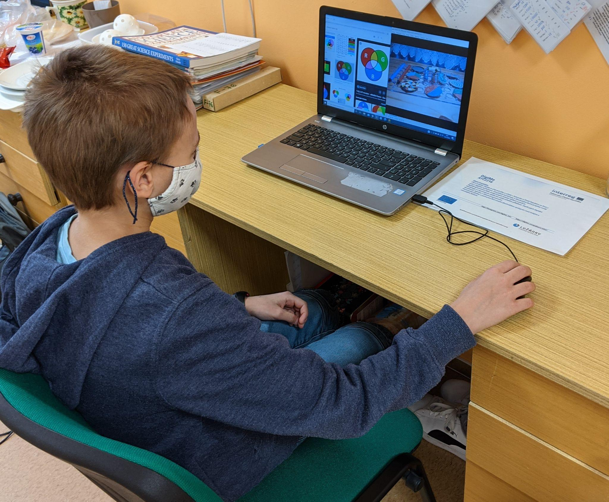
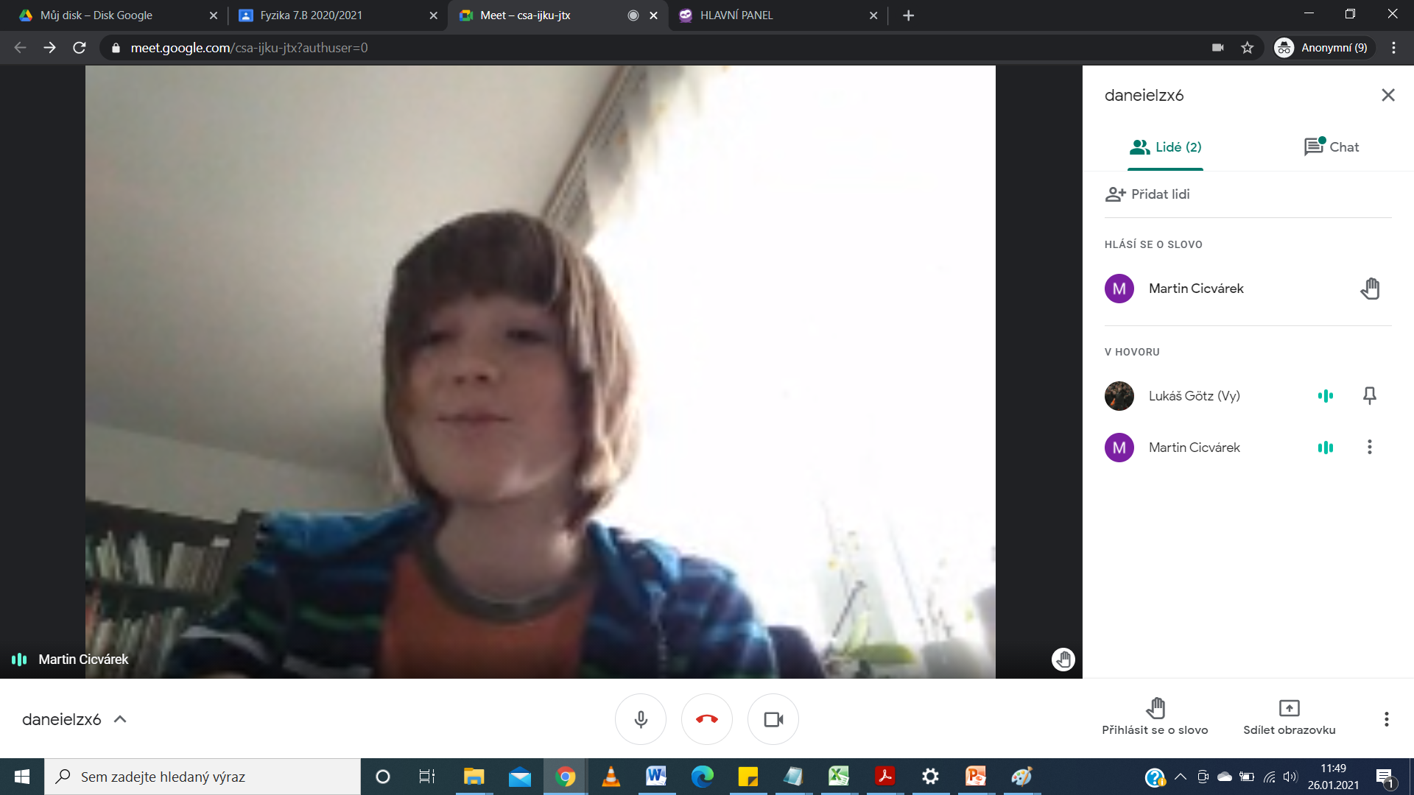
Needle magnet. Consultation online. Google Meet
Color stacking. Consultation.

If there was a miscommunication during the filmed sequence, which would have resulted in repeating the filming, possibly a significant part, we agreed that it would be easier to re-record only the audio track, which would replace the original passage in the video. For recording and editing, mostly free software – Audacity – was used. The last step was always to add an introduction and final "slide" with the project logo to the given video.
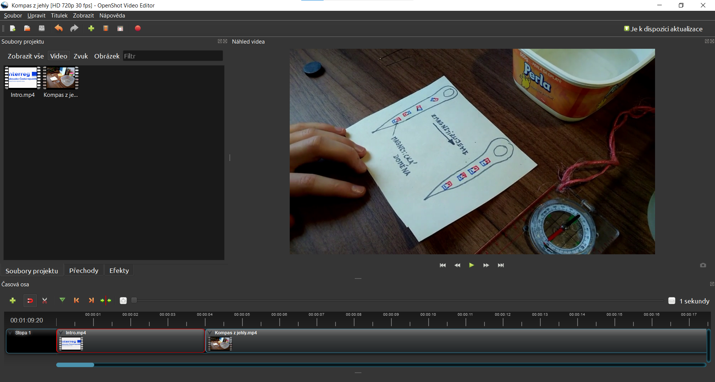
Needle magnet. Editing, cutting and supplementing the video with an introductory part. OpenShot Video Editor
Project evaluation and recommendations for work
Several different students across the school signed up to participate in the project, which was great, as everyone could work on topics related to the curriculum of the given year according to the SEP. However, some have chosen a topic that we haven't gotten to in class yet. This in itself did not represent a problem, but of course a thorough preparation for the subject matter and an explanation of the phenomena related to the experiment was necessary. This was not an obstacle in the end, as the students were even more motivated to carry out the experiment in a similar situation. Unfortunately, part of the intended set could not be realised. During the time when the project was running, teaching was conducted mainly by online learning, and a few students gradually lost their motivation and desire to continue with the project, which is a shame. In general, however, it can be stated that the students who participated in the project were enthusiastic and enjoyed the work.
Edited by: Lukáš Götz

Title of sub-project: Animated film
Project goal:
Within the framework of the creation of an animated film, the aim was for the students to become aware of the individual steps leading to the creation of a film in general and to also learn to work with the necessary technology.
Necessary equipment
- camera
- audio recorder
- tripod
- carriage
- video and audio editing software (e.g. Pinnacle, Video Editor Windows, Audacity, …)
Project phase
- Getting to know the principles of animation and the possibilities of the technique
In the first phase, it was necessary to explain to the pupils how the animation itself works. The first few classes were therefore dedicated to analyzation of various animated films/fairy tales in which different ways of working with the material are used, e.g.
"limited animation" - animation by cutting and moving static images (e.g. the fairy tale About the Golden Fish by Jiří Trnka from 1951, Available from https://www.youtube.com/watch?v=RfG0qmvq4h4&ab_channel=fantasysvet)
"flipbook" - animation in which a small notebook is used, the animation is created by flipping individual pages of the notebook, on which individual images/frames are drawn. The advantage is easy production (instructions are available e.g. here https://www.youtube.com/watch?v=Un-BdBSOGKY&ab_channel=Andymation)
"animation of silhouettes" - animation using elements of shadow play (we can also be inspired by the student project The Three Little Piggies https://www.youtube.com/watch?v=iCmFWJjc4RA&ab_channel=BeatsExotiques)
"claymation" - animation using a model (elements of this animation appear, for example, here https://www.youtube.com/watch?v=xCOZumo07Dc&t=147s&ab_channel=MarioCoroner)
"combined animation" - the animation uses both filmed footage, i.e. video, and animated footage (for inspiration, passages from Jiří Barta's Krysara from 1985 were shown, available here https://www.youtube.com/watch?v= OgL0OiFHSZY&ab_channel=NixFeratoo)
The purpose of these films was primarily to inspire the pupils and show them the various possibilities of animation and the rendering of a story.

- Audio track processing
Spoken word
In the next phase, the pupils had to be shown the pitfalls of working with sound, namely through the spoken word.
For this work, work in groups, the game Dixit and sound recordings, which they processed separately in the Audacity program, were used.
Pupils put together a story from the cards of the Dixit game.
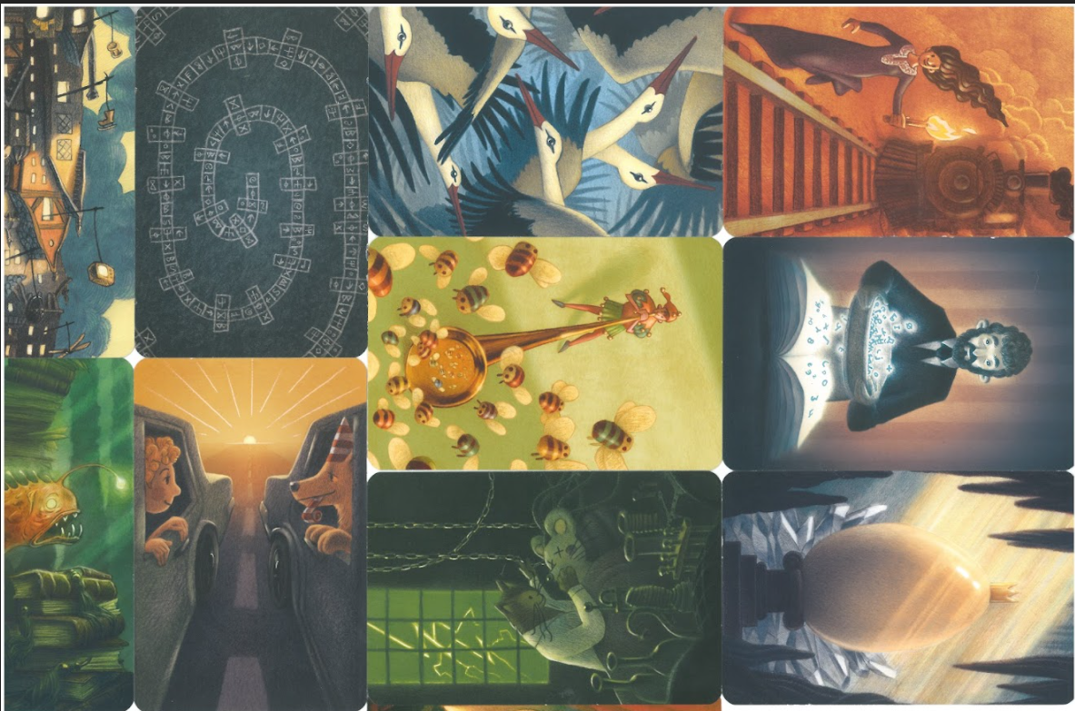

They wrote down its outline and wrote individual soundtracks for individual images.
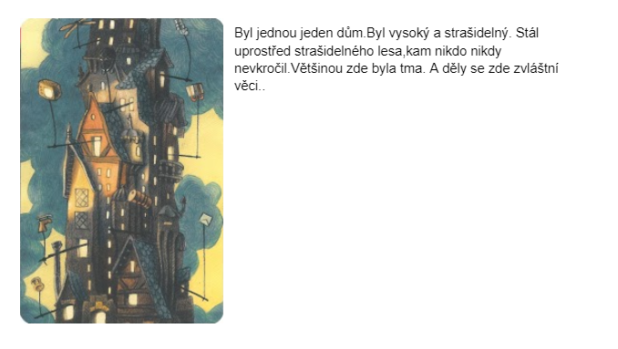
Example outline – image on the left, associated text on the right

Picture translation: Once there was a house. It was tall and scary. It was standing in the middle of a scary forest, where no one ever ventured. It was dark most of the times. And weird things were happening here...

In the next phase, the students recited the individual texts for the individual cards.
The students then assigned the sound to the individual slides in the Google Presentation application, in which the next slide was set to automatically start, so that the individual scenes alternated on their own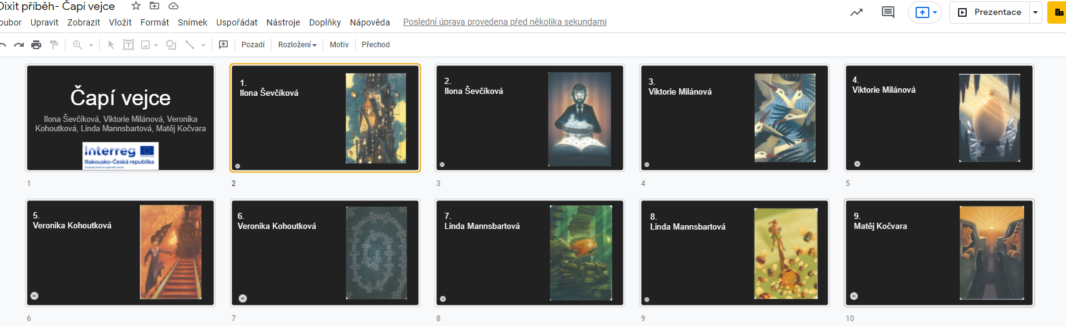
Thanks to this activity, the pupils became aware of the individual components of an animated film, as well as the difficulty of processing soundtracks.
TIP: It is better not to interrupt the recording of the audio track when a student makes a mistake, but to repeat the wrong sentence again with a small gap. Sound editing will then solve everything.

Background sound to the spoken word
In order for the students to become aware of the function of the individual sounds that can accompany both the audio recording and the video, a short excerpt was used, which the students had the task of accompanying any samples of sounds appearing in the text.
Text used:
"The forest offered peace to the knight. He rested in mossy silence. Sometimes a fly flew past his ear. He tiredly listened to the occasional rustle of leaves in the treetops. The birds were flying in the branches of the trees, fighting for food or a better place on the branch. Behind him a brook gurgled, which, however, could not drown out the sounds of the distant battle, the clanking of armour and swords clashing in close combat.
Pupils searched for sound effects on the internet (e.g. https://mixkit.co/free-sound-effects/, https://freesound.org/, …)
TIP: For individual samples, it is good to pay attention to the blending of sounds, the use of fade in and fade out or the doppler effect, etc.)
Video creation
choosing a topic
The most important thing for the actual creation of the animated film was the decision of what topic would be covered in the film. This topic subsequently also determined what type of animation will be mainly used.
The brainstorming method was chosen for the initial shot, from which the idea for a video gradually crystallised. The video will somewhat introduce the viewer to the school premises.
Real objects and environments will be used for the animation, and in rare cases they will be processed in a graphics program.
creation of a scenario and description of individual scenes
Due to the involvement of the whole class (i.e. 26 pupils), it was also necessary to devise a proportionate number of individual scenes and divide the individual functions accordingly.
Each group had the task of preparing the scenario of their own scene (a description of what will happen, including sketches of individual shots).
The scenes of the individual groups were then put together as a whole video.
shooting schedule
Due to the number of groups involved, it was also necessary to plan the time schedule of individual filming. The students had to take into account the daily filming time, including the weather. The real environment is largely influenced by natural light from outside.
it was agreed between the groups that the minimum frame rate would be 10 fps (i.e. a minimum of 10 frames needed to be taken per second of real footage)
- camera settings were fully automatic
- the pupils had a tripod, a Fujifilm XE3 camera at their disposal during the filming, the self-timer proved to be very useful, it is advisable to use a dummy battery for filming a scene in the form of a time-lapse, so that the camera could be powered from the mains, so that the recording did not end just because the battery ran out
- a cart was used for "connecting" scenes / passages through spaces
- the audio track was recorded last after the entire video track was finalized so that the audio track would match the footage appropriately
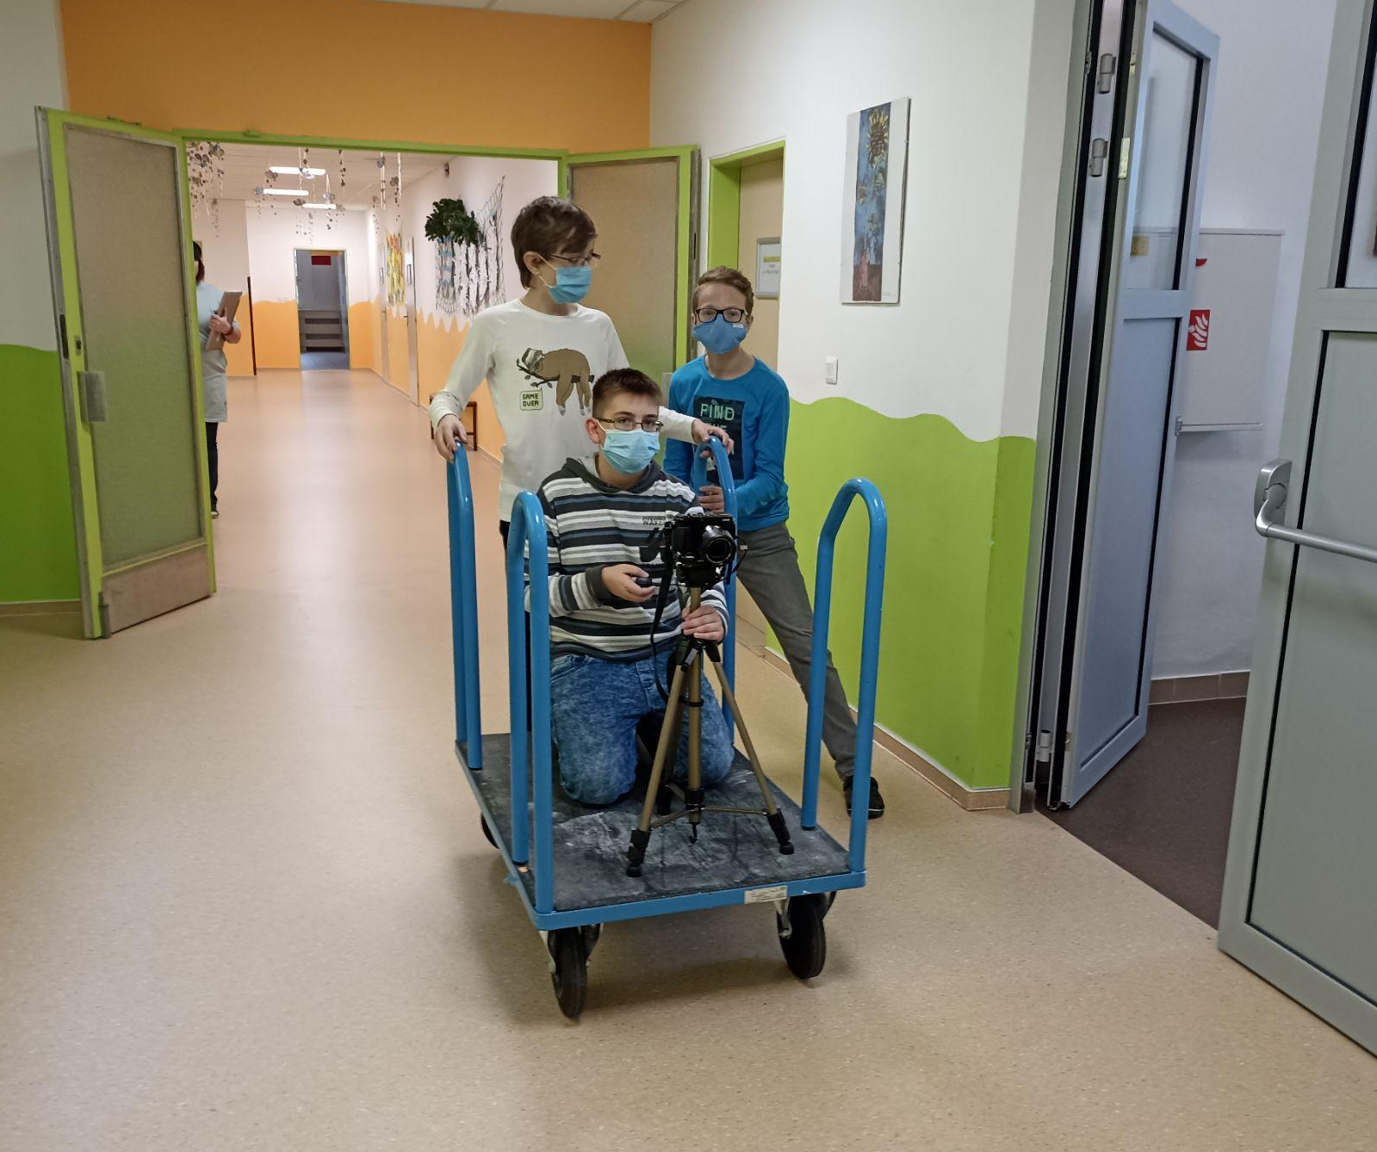
Use of the wheelchair during the night doing

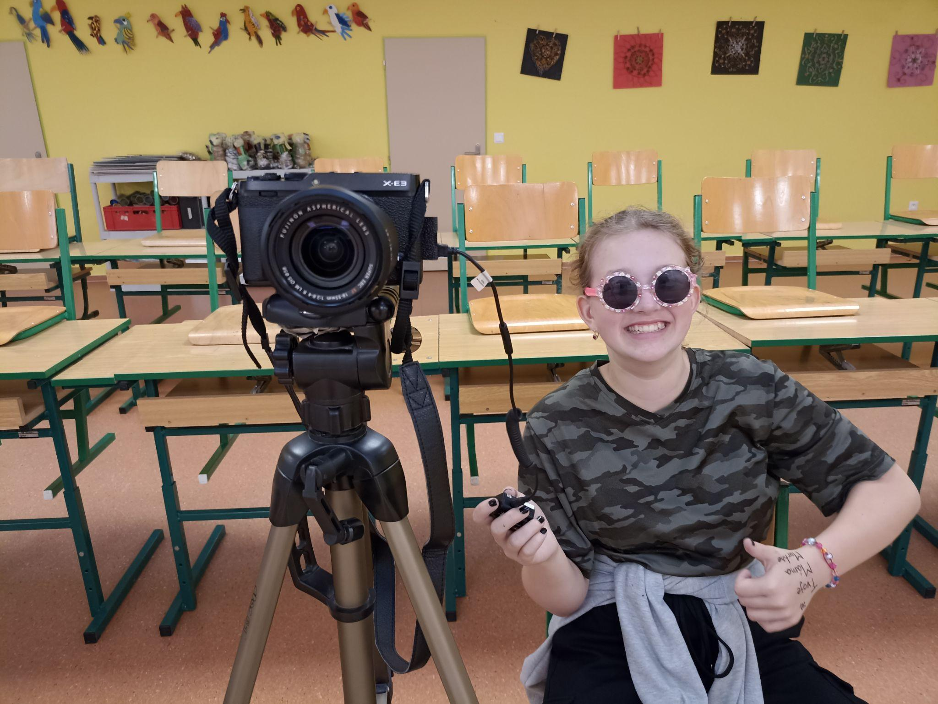
The hard work of a photographer who presses the shutter button

Material processing
This is one of the most demanding stages. Each group had to go through all the pictures taken and discard the ones that didn't work.
Common errors:
- wrong composition
- the image shows the animator or some of his body parts
- a prop that should not be in the frame appears on the image
- the animator can be seen in the reflection or his shadow can be seen in the image
- a stranger appears in the picture. He has no idea that he has just entered the frame
The individual frames were then imported into the video editor, where the appropriate duration was set, mostly between 0.1-0.05 s, to ensure the smoothness of the animation.
Individual scenes were subsequently exported to mp4 format in 1920x1080 quality.
video finalisation.
The individual scenes were assembled into a continuous video in the video editor in the sequence determined by the script, or they were enriched with still missing passages and one main video file was exported from them.
A soundtrack and subtitles were also added to it.
A predetermined pupil was responsible for the final finalisation at each step, as the group's work would be useless at this point.

Project evaluation and recommendations for work
The project fulfilled its primary goal, as the students mastered the handling of audio and video technology, realised the demanding work of animators and the necessity of preparation before producing a multimedia message.
Initially, the students were well motivated to work. However, due to the hygiene measures that prevented continuous attendance during the project, it was difficult to keep the motivation of the students, especially in the final of the work itself.
It is therefore important to have the individual phases of video creation clearly defined and prepared before the students start filming. This will make filming much more efficient.
At the beginning of the entire project, it is also good to be aware of the technical parameters involved in processing such a large amount of data. Importing photos into the video editor can sometimes take tens of minutes on school PCs. The finalisation of individual scenes was therefore handled by individual students who were willing to process the material.
When you decide to make a film with your students (no matter whether animated or live), it is generally advised to start with a short format, on which the students will become aware of the possibilities and techniques of how to work. It will then help them come up with a theme that will be covered in the film. The very idea of what the film will be about and how it will be processed is probably the most important thing for the students. If the idea comes from the students and they enjoy it, they will participate in its creation with joy and willingness, and they won't even notice that they are learning something new along the way.
Edited by: Štěpán Jirků

